

**National Italian Examination**

**Test Administration Instructions**

**THIS DOCUMENT IS CONFIDENTIAL.**

**NO STUDENT IS TO BE GIVEN ACCESS TO THIS DOCUMENT.**

**General instructions:**

1. What you say is **"in bold within quotation marks."**
2. What you do is written in normal type.
3. What you observe is [within brackets].

|  |
| --- |
| **SECRET WORDS** |
| Secret words needed to access the exams were e-mailed to teachers separately. Teachers should print out the secret words and have them ready to provide to the students. Secret words are NOT to be given to the students until they have logged into the test. |

A few days prior to students' testing session:

* Make sure that you have devised a plan to give students their **usernames** and **passwords** on the day of the test.
* Log into your Quia account and make any last-minute changes as outlined in the e-mail that accompanied this document.
* Verify with the computer technicians that the computers are up to date with the latest available operating system and browser patches. Running these operating systems and browsers without the latest patches is hazardous and may prevent certain Quia features from working properly.

|  |
| --- |
| Windows XP, Vista, 7, 8   * Internet Explorer 8, 9, 10 * Mozilla Firefox * Google Chrome |
|  |
| Macintosh OS X   * Safari 3, 4, 5, 6 * Mozilla Firefox * Google Chrome |

In addition, we strongly recommend reviewing Quia's technical requirements at

[http://www.quia.com/help/tech/system-requirements.html](http://cwww.quiacorp.com:9110/help/tech/system-requirements.html)

Immediately prior to students’ testing session:

* Turn on all computers.
* Using the instructions sent to you by Quia in the e-mail accompanying this document,   
  **log in to your Quia account** in case you need to use it for any of the reasons outlined in the accompanying e-mail.
* It is suggested that you open up the correct Internet browser and have the page <http://www.quia.com/web> already on the computer screen when the students arrive. This will present one less step for student error to slow down the log in process.
* Know to which computers students will be assigned when they arrive.
* Secret words to access the exams were e-mailed to you. Print out the secret words and have them ready for use during Instruction 7 below.

When students arrive for testing session:

* Assign each student to a computer station.
* Give each student his/her username and password.
* Instruction 1: Say: **"Please take your assigned seat and wait for my instructions. It is important that you do not touch the computers until instructed to do so."**[when all students have been seated]  
  Say: **"Today you will be taking the online National Italian Examination. We will access the National Italian Exam through the Quia website."**If you have already set the browsers to the Quia website, skip instruction 2 and proceed to   
  instruction 3.
* Instruction 2: If you have not set the browsers to the Quia website, say:   
  **"Open up your Internet browser and go to http://www.quia.com/web."**Make sure that the students open up the correct Internet browser and are all at the Quia website. When all students are at the website, proceed to instruction 3.
* Instruction 3: Say: **"Where it says ‘Quick Login,’ enter your username and password."** When all students are at the following page, look at the page with them.

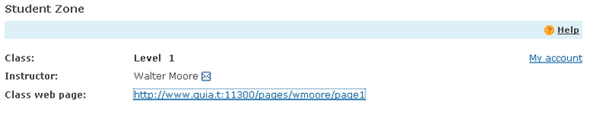

* Instruction 4: Say: **"Click on the class web page link."**
* Instruction 5: After you have finished reading the instructions on the page, say: **"Click on the link of the exam you are taking today. *You will only have one attempt per exam."***
* Instruction 6: When the students have the following log in screen up, say: **"Do not type in any usernames or passwords until I have finished the instructions. When you type in your username and password, be careful to type them in accurately. They do not have any spaces before or after them. You will only have one attempt per exam, so you must log in correctly in order to take the exam. After you have typed in your username and password, click the start now button and wait for the rest of the group. Go ahead and type in your username and password."**

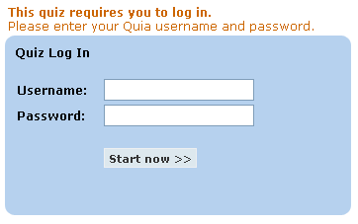

🡸 Enter your username and password.

Instruction 7: When the students have the following "secret word" screen up, say: **"In order to access today's exam you will need a secret word. After you have typed in the secret word, click the start now button and wait for the rest of the group. The secret word is: __________________"**

If you give out an incorrect secret word, the student could log in to another test from home. Students who log-in incorrectly will be disqualified, as the computer log will show what date and time the student logged in to the exam.

|  |
| --- |
| **SECRET WORDS** |
| Secret words needed to access the exams were e-mailed to teachers separately. Teachers should print out the secret words and have them ready to provide to the students. |



🡸 Enter the secret word provided by your teacher.

Instruction 8. Read the instructions for the exam:

**In addition to being a tool to assess your knowledge of Italian, the National Italian High School Contest Examination is also a contest. Please provide the following information so that your test score will be entered correctly for your level and category. Failure to complete the information correctly will result in your disqualification from the contest.”**

**Then tell the students: "Type in your first name." Pause.**

**"Type in your last name." Pause.**

**"Type in the name of your school." Pause.**

**"Scroll down and select the state where your school is located. You need to know that scroll boxes are a little tricky to use. Immediately after selecting your state, you need to click outside of the scroll box in order to lock in your response. If you don't click outside of the box, you can inadvertently change your answer. You should remember this as you complete the test. If an answer is a in a scroll box, make sure that you click outside the box to lock in your answer."**

**"Type in your teacher's last name." Pause.**

**"Type in your teacher's first name." Pause.**

**"Choose your sex. Remember to click outside the scroll box to lock in your answer." Pause.**

**"Select your grade. Remember to click outside the scroll box to lock in your answer." Pause.**

**"Answer questions 9 and 10 and declare your category." Pause.**

**“PLEASE NOTE: Failure to declare a category will result in your score being disqualified.”**

**Go to Instruction 9 on the next page.**

Instruction 9: Say: **"This is the end of the student information section. Please look at the warning in the box."** Pause. **"For security purposes, copying, pasting, printing and any other features using the control key have been disabled.**

**You are not allowed to have any other window open during this examination. Opening any other window will immediately disqualify you.**

**I will be moving around the room while you are taking your exam.**

Teachers/proctors are expected to walk around the room to supervise and make sure the integrity of the test is not compromised.

**Once you have completed the exam and answered all of the questions, click *Submit answers* to submit the exam. Remember, clicking *Submit answers* will submit the exam. There is no way to go back and change your answers after the exam is submitted. Be sure to review your answers before submitting. After you click *submit answer****s* **your exam will be computer graded and your score will be sent to your teacher in early May. Also, if you save your username and password, you will be able to log back into your test after May 1 and see your answers as well as the correct answers for any questions your missed."**

🡸 Clicking *Submit answers* will submit the exam. There is no way to go back and change your answers after the exam is submitted. Be sure to review your answers before submitting.



Say: **"Good luck. You have 60 minutes to complete this examination. You may now begin the National Italian High School Contest Examination."**

Look at the clock, add 60 minutes to the current time and post the end time on the board.

**Additional Information:**

Technical Support

Technical support for the National Italian High School Contest Examination is available to assist with any questions you may have. For non-urgent requests, please contact support at help@quia.com. For requests that require immediate assistance, please contact support Monday - Friday from 7:30 am to 8:00 am (Eastern Time) by calling (855) 883-4800 and from 8:00 am to 8:00 pm (Eastern Time) by calling (877) 282-4400, press #3.

**Print Required Documents**

Print out the three (3) items sent to you via e-mail

1. The E-MAIL which contains USERNAMES and PASSWORDS

2. The separate E-MAIL you received with SECRET WORDS

3. This ADMINISTRATION MANUAL

**Arrange Accommodations for Students with Special Needs**

Students with an IEP who receive accommodations under IDEA guidelines on standardized examinations may receive the same accommodations on the National Italian High School Contest Examination. **You must make arrangements at least one week prior to exam day**. To make arrangements for students with special accommodations, send a copy of the student’s IEP in an email to [aati@utoronto.ca](mailto:aati@utoronto.ca) or [l.maiellaro@neu.edu](mailto:l.maiellaro@neu.edu) with the following information:

* Teacher name
* Teacher’s e-mail address
* National Italian High School Contest Confirmation Number
* School Name
* Student Name
* Required accommodation (ex: about of additional time needed.)

Adding Students or Changing Student Registrations

Once you have registered for the National Italian High School Contest Examination, you can add additional students to your roster or make corrections to a student’s name, grade level, or exam level.

**Making Corrections to Your Registration**

To make corrections or additions to your registration before you receive your USERNAME and PASSWORD from Quia, go to https://secure.quia.com/nieorder and sign in using your e-mail address and the REGISTRATION CONFIRMATION NUMBER you received in the e-mail confirming your registration.

Once logged in, you may add students to your registration or correct the spelling of a student name, or change a student name, grade level, and/or exam level. After making necessary additions or corrections, click “Continue” at the bottom of the screen, review the information, and click “Submit Registration” to submit the changes.

**Making Corrections to Your Exam Rosters**

Once you have received the USERNAME and PASSWORD sent to you in an e-mail from Quia, changes in your student roster can only be made by logging in to your National Italian High School Contest Examination Quia account at www.quia.com/web using the USERNAME and PASSWORD contained in the e-mail. When you log into your National Italian High School Contest Examination Quia account, the students you registered for the exam appear on the class roster at the level for which they are registered. To see a student’s password, click on the lock icon next to a name. You may add additional students to your roster or change a student’s exam level up to exam day.

**Adding New Students**

If you would like to register additional students to take the exam, follow these steps:

1. Log in to your National German Exam Quia account using the USERNAME and PASSWORD which was sent to you in an e-mail from Quia.

2. Navigate to the appropriate class roster using the Class drop-down menu in the upper left.

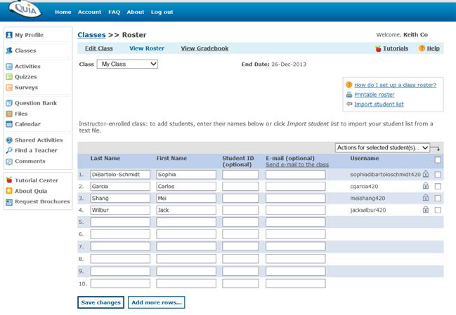

3. Type the student’s first and last names into the blank rows of the roster. If you are adding several students and run out of space, click "Add more rows..." to add additional rows at the bottom of the roster.

4. When you have added all the students, click "Save changes". A USERNAME and PASSWORD will be generated for each new student. To see a student’s PASSWORD, click on the lock icon next to the student’s name.

If you add any additional students, you must pay exam fees for these students BEFORE any scores will be released to your school. Please note that adding new students requires that you pay the exam fee of $6.00 for each new student registered. You may pay via PayPal at the (will need the PayPal Link) or send payment to:

Enza Antenos-Conforti

AATI Secretary/Treasurer

43 Mt. Prospect Avenue

Verona, NJ 07044

**Making Substitutions**

If you need to substitute a student, simply add him or her to the roster for the appropriate level and ignore the entry for the original student. As long as the original student does not take the exam, you will not be charged an additional fee. To substitute a student, please follow these steps:

1. Log in to your National Italian High School Contest Examination Quia account using the USERNAME and PASSWORD which was sent to you in an e-mail from Quia.

2. Navigate to the appropriate class roster using the Class drop-down menu in the upper left.

3. Type the student’s first and last names into the blank rows of the roster.

4. Click "Save changes". A USERNAME and PASSWORD will be generated for the new student. To see a student’s PASSWORD, click on the lock icon next to the student’s name.

5. Ignore the original student’s name on the exam level roster.

**Changing a Student's Exam Level**

If you need to change the level for which one of your students is registered, follow these steps:

1. Log in to your National Italian High School Contest Examination Quia account using the USERNAME and PASSWORD which was sent to you in an e-mail from Quia.

2. Navigate to the appropriate class roster using the Class drop-down menu in the upper left.

3. Type the student’s first and last names into the blank row on the roster.

4. Click "Save changes". A new USERNAME and PASSWORD will be generated for that student. Be sure that the student uses the new USERNAME when taking the exam in order to access the correct level exam.

5. Ignore that student’s name on the original exam level roster.

**Students Not Taking the Exam**

If your roster contains students who will no longer be taking the exam, simply ignore their names on the roster. You cannot delete any students' names, and there is no refund.

**Providing Students with Additional Attempts**

Each student may take the 2016 National Italian High School Contest Examination only once. Students are automatically barred from taking the exam multiple times. However, if something goes wrong the first time a student takes a section of the exam – for example, if the power goes out, the Internet connection fails, or the student accidentally hits the "Submit" button before completing the test – you can add attempts for individual students.

Additional attempts may not be added if a student simply runs out of time.

To add an attempt for a student, follow these steps:

1. Log into your National Italian High School Contest Examination Quia account using the USERNAME and PASSWORD which was sent to you in an e-mail from Quia.

2. Click the "Quizzes" link in the upper left corner.

3. Click the folder next to the student's exam level.

4. Click "Add attempts" next to the exam for which you want to allow an extra attempt.

5. Change the number of attempts to 2 using the drop-down menu labeled "Attempts" next to the student's name.

6. When you are finished, click "Done".

The student will now be able to log in and attempt the exam a second time using the USERNAME and PASSWORD they were provided.